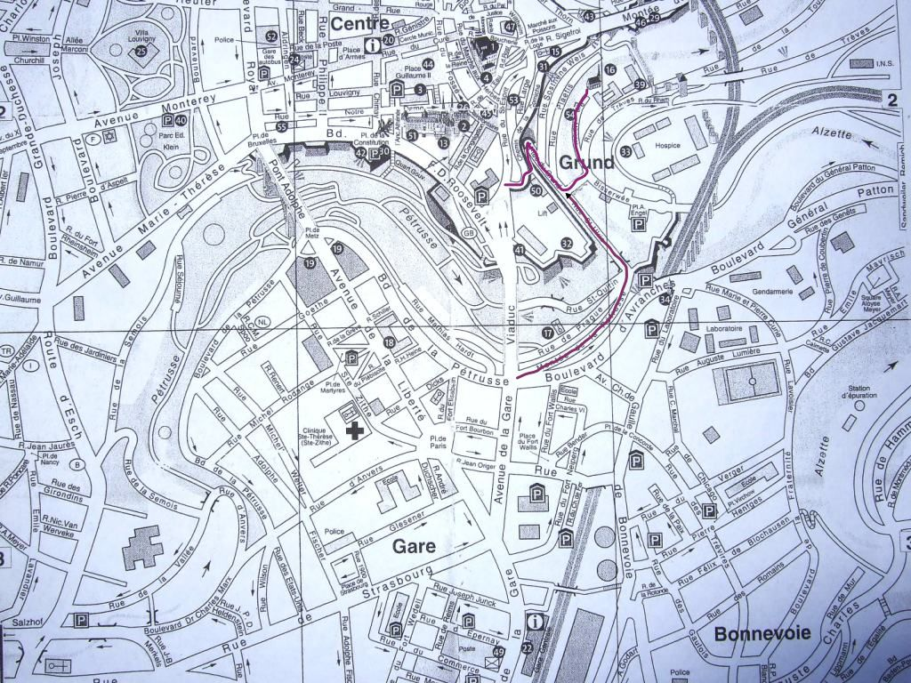
A
B
E
C
D
Train station
Employability:
The Employers’ Perspective and its Implications

Official Bologna Seminar
6-7 November 2008
Luxembourg

Meeting venue:
Abbaye de Neumünster (16)

Hotels:
A: Parc Belle-Vue and
Parc Plaza

B: Golden Tulip
Central Molitor

C: Hotel Français

D: Art Hotel Simoncini

E: Grand Hotel Alfa

